Template for Evidence(s)
UI GreenMetric Questionnaire

University : TUNGHAI UNIVERSITY
Country : TAIWAN
Web Address : http://www.thu.edu.tw

[5]Transportation (TR)
[5.5] Shuttle service (TR.2)
[5] Shuttle service is provided by the university, regular, and zero emission. Or shuttle use is not possible (not applicable)

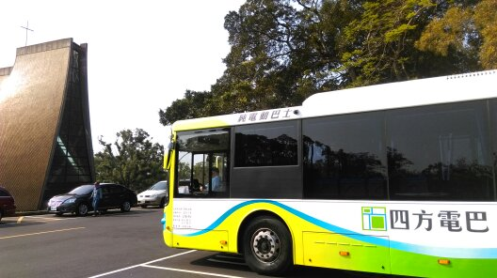 | 