Template for Evidence(s)
UI GreenMetric Questionnaire

University : TUNGHAI UNIVERSITY
Country : TAIWAN
Web Address : http://www.thu.edu.tw

[5] Transportation (TR)
[5.16] Pedestrian path policy on campus
[5] Pedestrian paths are available, designed for safety, convenience, and in some parts provided with disabled-friendly features

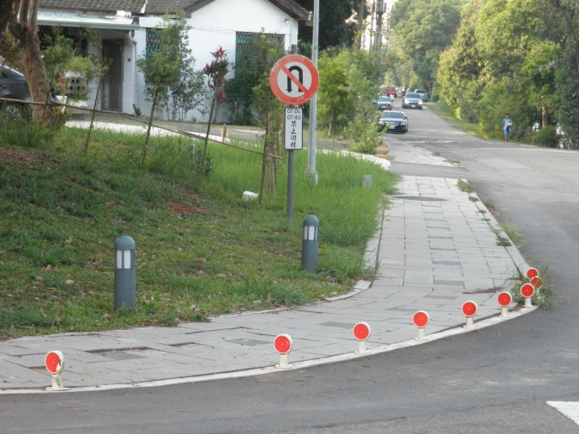 | 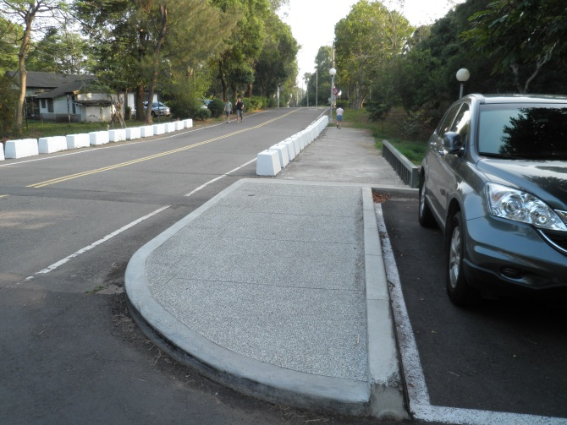
Example of pedestrian path (Tunghai University, ROC) | Example of pedestrian path(Tunghai University, ROC)
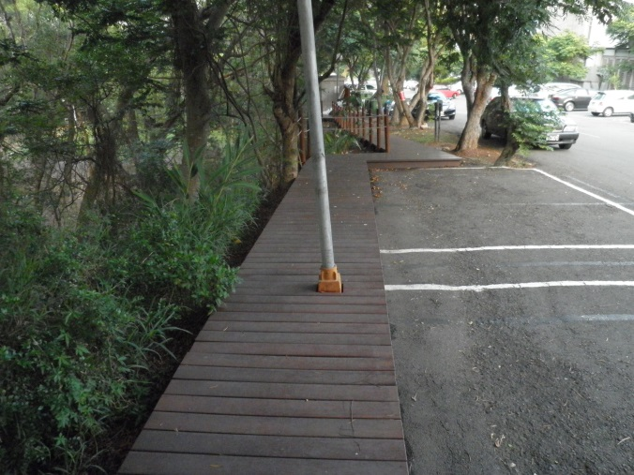 | 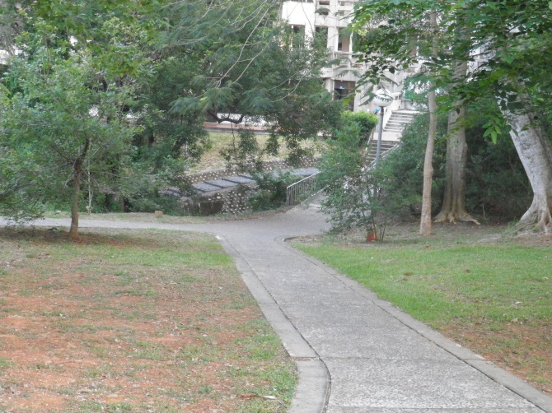
Example of pedestrian path (Tunghai University, ROC) | Example of pedestrian path(Tunghai University, ROC)

Description:
- Separator between road for vehicle and pedestrian path
- Separator between road for vehicleeparator between road for vehicle
- Wooden pedestrian path
- Ramps and guiding blocks which have suitable design for pedestrian having physical disabilities.

