Template for Evidence(s)
UI GreenMetric Questionnaire

University : TUNGHAI UNIVERSITY
Country : TAIWAN
Web Address : http://www.thu.edu.tw

[5] Transportation (TR)
[5.13] Ratio of parking area to total campus area
[5] < 1%

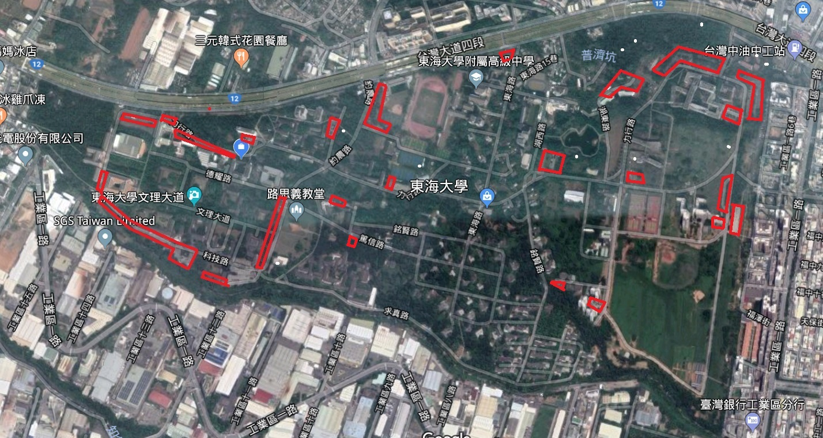

Description:
Total Parking area = 11293 m2
Ratio parking area : 0.8%

