Template for Evidence(s)
UI GreenMetric Questionnaire

University : TUNGHAI UNIVERSITY
Country : TAIWAN
Web Address : http://www.thu.edu.tw

[4] Water (WR)
[4.1] Water Conservation Program Implementation
[5] > 50% water conserved

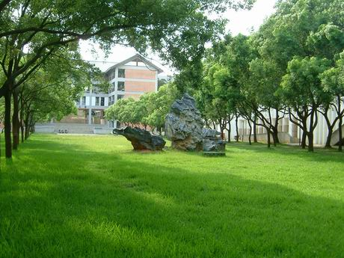
1
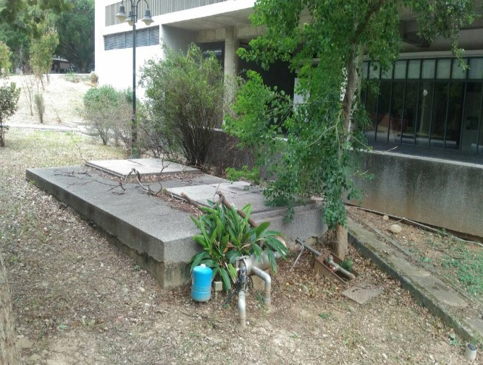 | 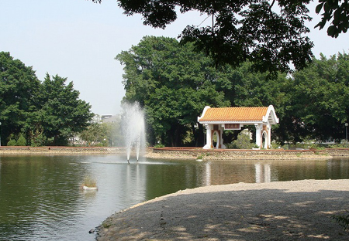
2 | 3

Description:
- 建置相思林雨水回收再利用系統
- 建置人文大樓雨水回收再利用系統
- 建置東海湖作為天然的雨水貯存池（生態池）

