Template for Evidence(s)
UI GreenMetric Questionnaire

University : TUNGHAI UNIVERSITY
Country : TAIWAN
Web Address : http://www.thu.edu.tw

[3] Waste (WS)
[3.2] Program to Reduce The Use of Paper and Plastic in Campus
[5] More than 3 programs

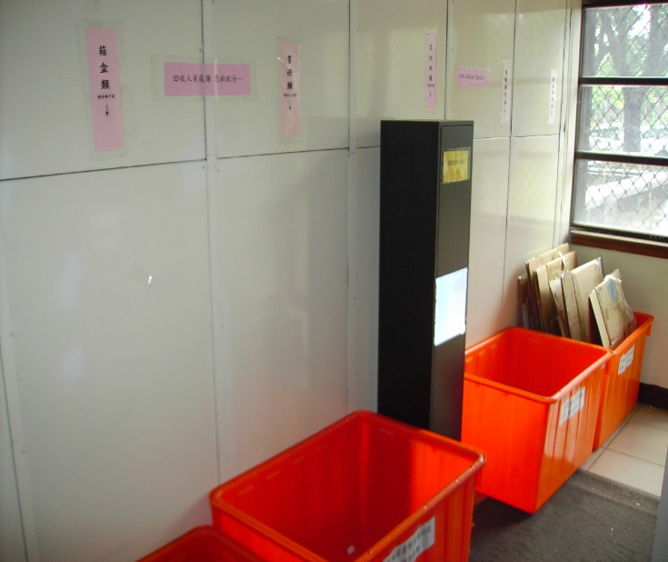 | 