Template for Evidence(s)
UI GreenMetric Questionnaire

University : TUNGHAI UNIVERSITY
Country : TAIWAN
Web Address : http://www.thu.edu.tw

[2] Energy and Climate Change (EC)
[2.11] Please provide the total carbon footprint (CO2 emission in the last 12 months, in metric tons)

2018年度co2量(用電量)
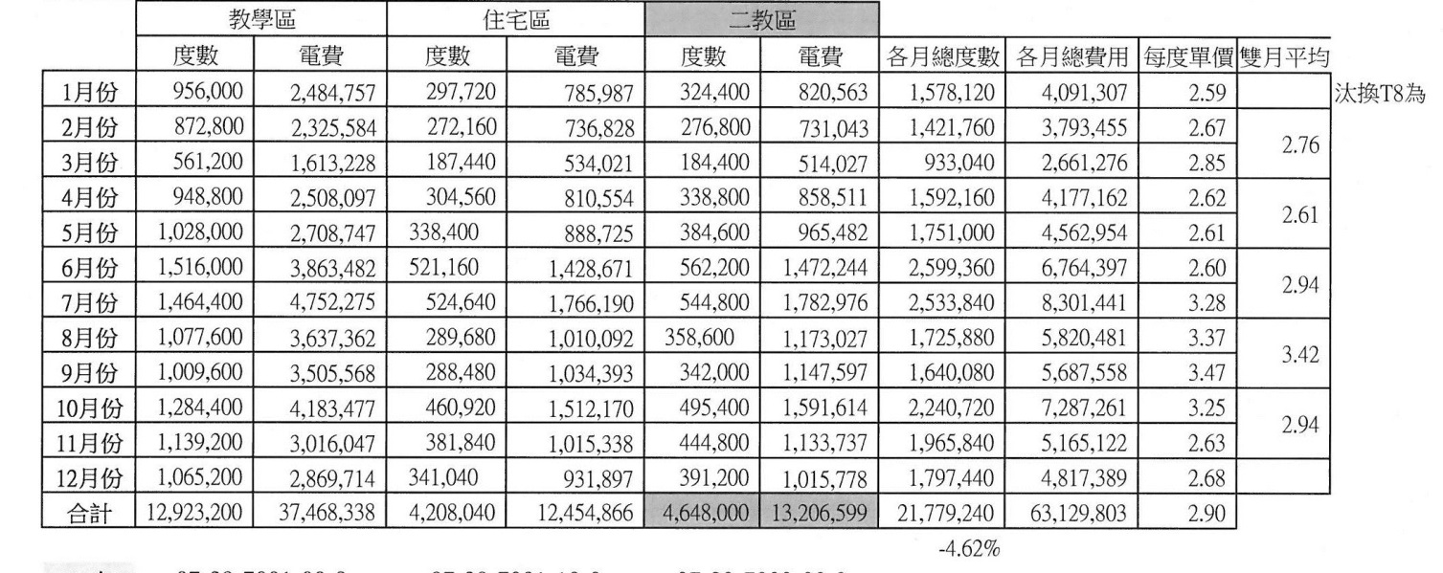

Description:
........... 用電量21779240度×0.638 kg/1000=13895.2 (co2噸)
..........汽車進入量(3607×2×0.5公里×240/100)×0.02=173.1 (co2噸)
......... 機車進入量(1463×2×0.5公里×240/100)×0.01=17.5 (co2噸)
......... 13895.2 (co2噸)+ 173.1 (co2噸)+ 17.5 (co2噸) =14085.8 (co2噸).
..........................................................................................................................................................................
..................................................................................................................................................................
..................................................................................................................................................................

